Docker-2
- Create a tomcat container on 8080 and deploy sample application in tomcat.
Verified the docker status running or not
systemctl status docker
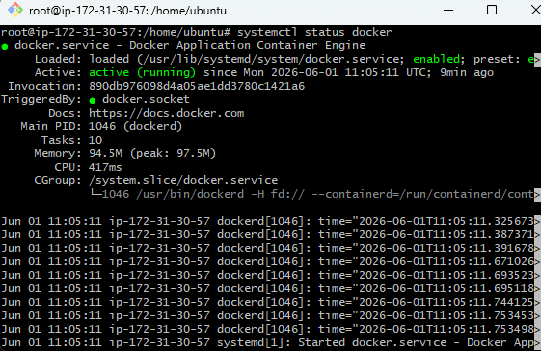
Pull Tomcat Image. Downloaded the Tomcat image
docker pull tomcat:latest
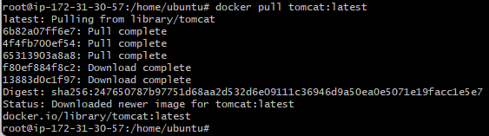
Verify docker images
docker images
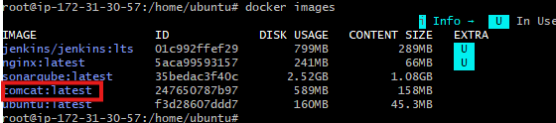
Create Tomcat Container and Run Tomcat on port 8080
docker run -d --name tomcat-server -p 8080:8080 tomcat:latest
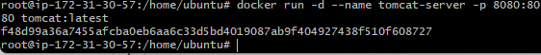
Verify Container is Running
Docker ps
Login to the running Tomcat container
docker exec -it tomcat-server bash
Navigate to the Tomcat deployment directory
cd /usr/local/tomcat/webapps
pwd
Update package repositories inside the container:
apt update

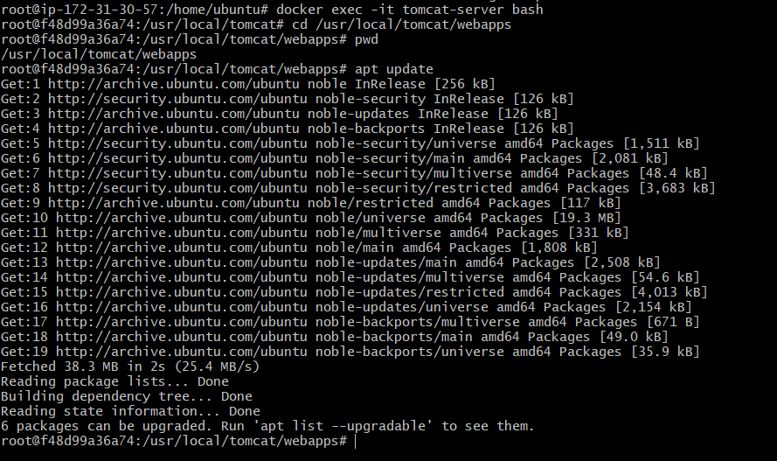
apt install wget -y
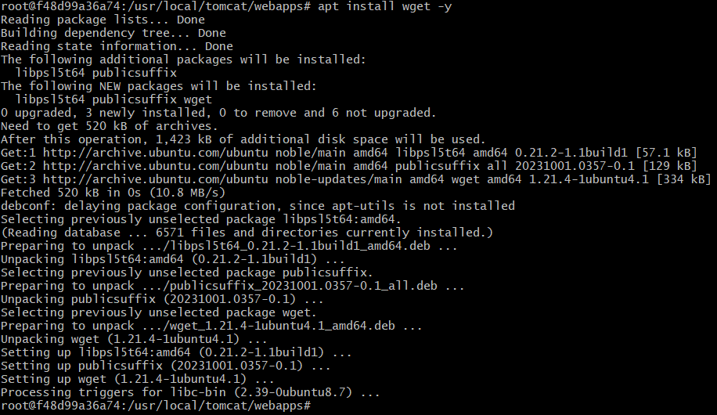
Download Sample WAR File
wget https://tomcat.apache.org/tomcat-7.0-doc/appdev/sample/sample.war

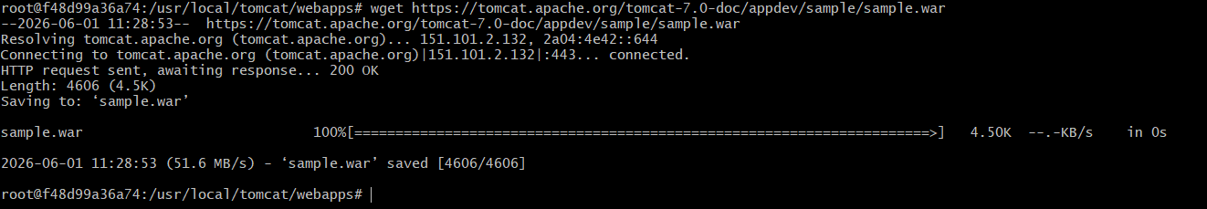
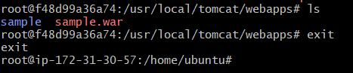
verify Application Deployment Using Docker Logs
docker logs tomcat-server
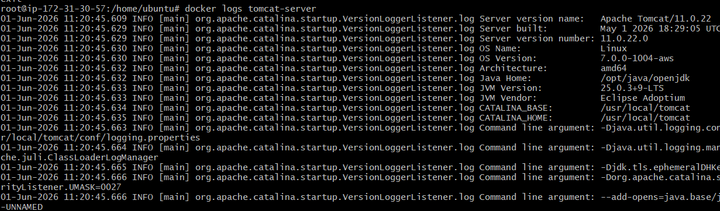
docker ps
docker exec -it tomcat-server bash
cd /usr/local/tomcat/webapps
ls -lrt
exit
curl -I http://localhost:8080/sample
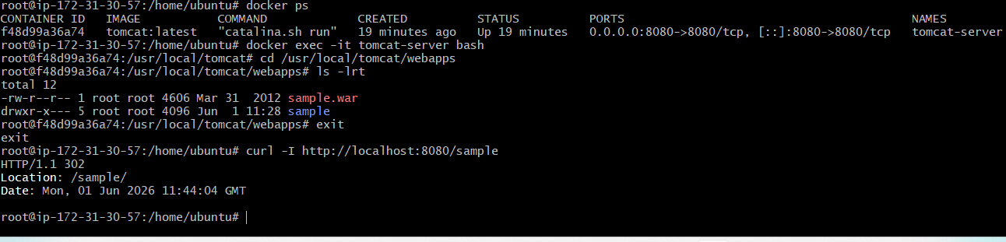
Successfully created a Tomcat Docker container on port 8080, deployed the sample.war application.
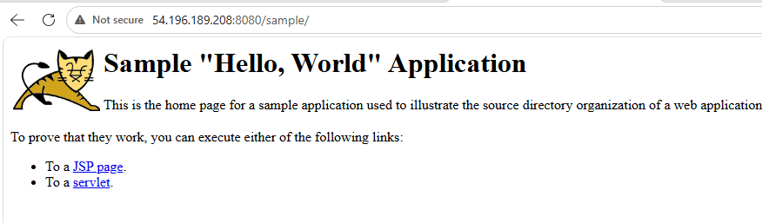
- Create volume and deploy tomcat container on port 8081.
Create Docker Volume
docker volume create deployment
Verify Volume
docker volume ls
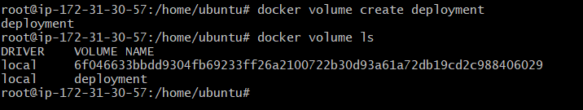
Check Volume Location
docker volume inspect deployment
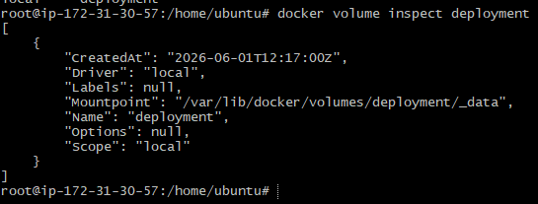
Download Sample WAR File into Volume
cd/var/lib/docker/volumes/deployment/_data
wget https://tomcat.apache.org/tomcat-7.0-doc/appdev/sample/sample.war
ls -lrt
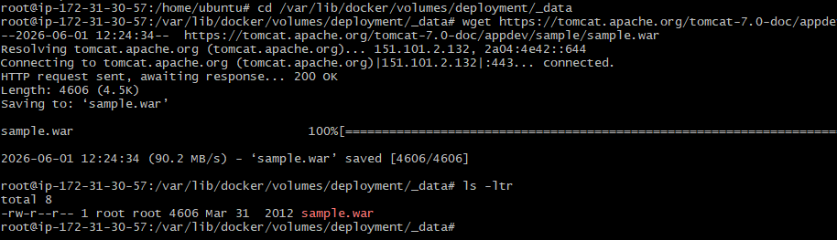
Deploy Tomcat Container Using the Volume
docker run -d \
--name tomcat-volume \
-p 8081:8080 \
-v /var/lib/docker/volumes/deployment/_data:/usr/local/tomcat/webapps \
tomcat:latest
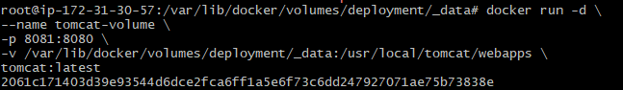
docker ps
Verify Deployment Logs
docker logs tomcat-volume
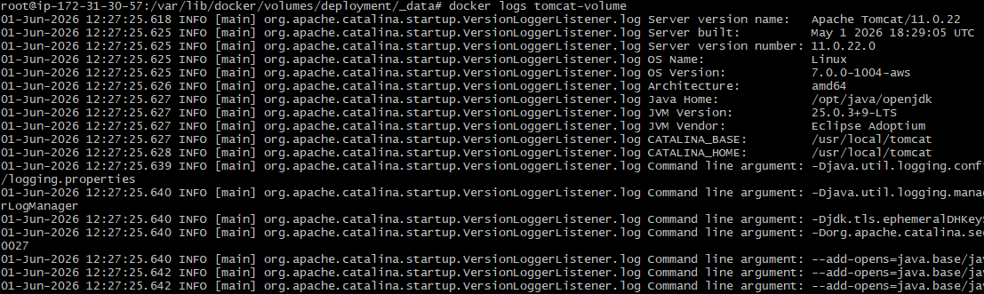
curl -I http://localhost:8081/sample
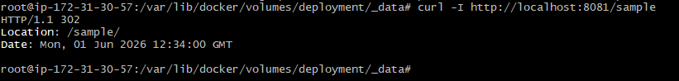
Successfully created a Docker volume and deployed a Tomcat container on port 8081.
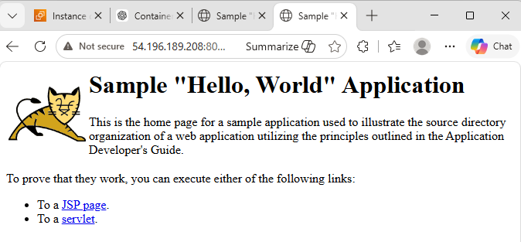
- Limit the nginx container to 500 MB.
Pull Nginx Image
docker pull nginx:latest
docker images
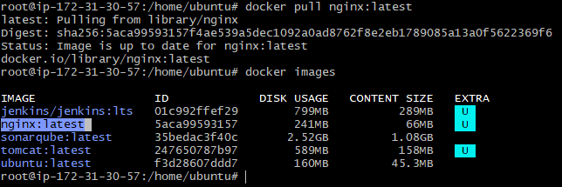
Run Nginx Container with Memory Limit
Command
docker run -d \
--name nginx-limit \
-p 8082:80 \
--memory=500m \
nginx:latest
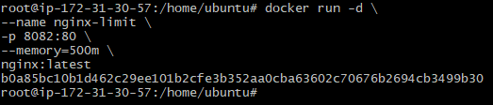
docker ps
verified the limit using the docker stats command.
docker stats
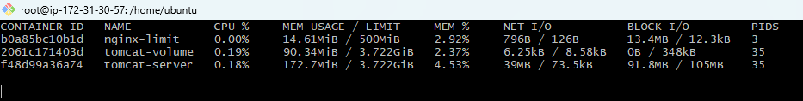
Successfully created an Nginx container with a memory limit of 500 MB.
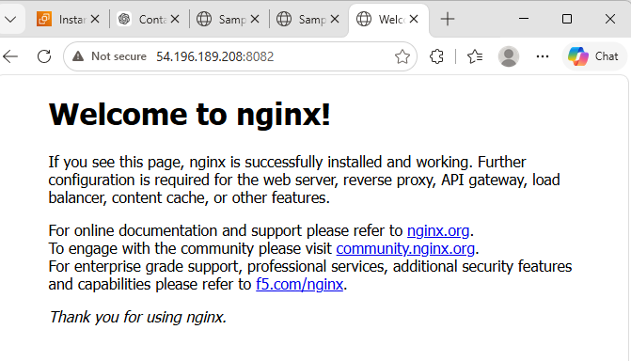
- Create a sample docker file using below instructions.
  - Base module as amazonlinux:latest
  - Maintainer you name
  - Install nginx
  - COPY one index.html file to image
  - Expose on port 80
  - Command to start the nginx container
Create index.html
vi index.html
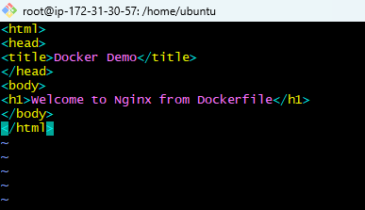
Create Dockerfile
vi Dockerfile
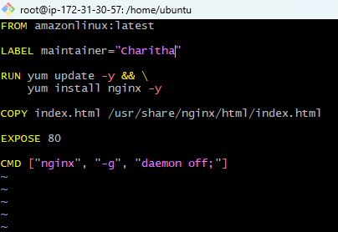
Build Docker Image
docker build -t nginx-custom:v1 .
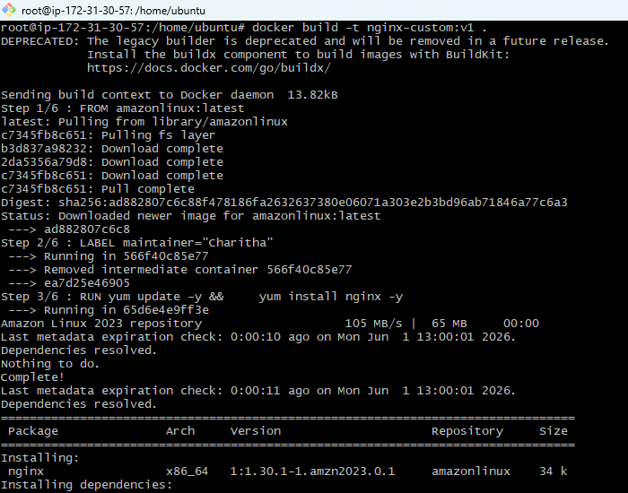
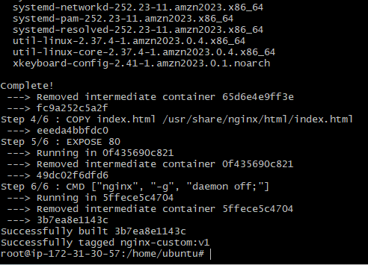
docker images
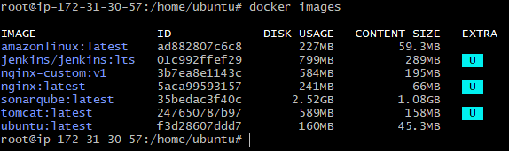
Run Container
docker run -d \
--name nginx-custom \
-p 8083:80 \
nginx-custom:v1
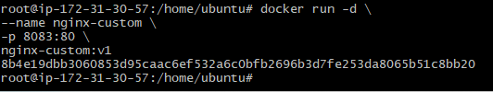
docker ps
Successfully created a custom Docker image using a Dockerfile with amazonlinux:latest, installed Nginx, and copied a custom index.html file.
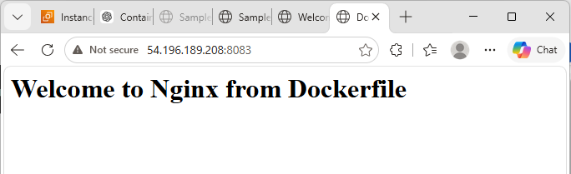
- Push image to Docker hub
docker login
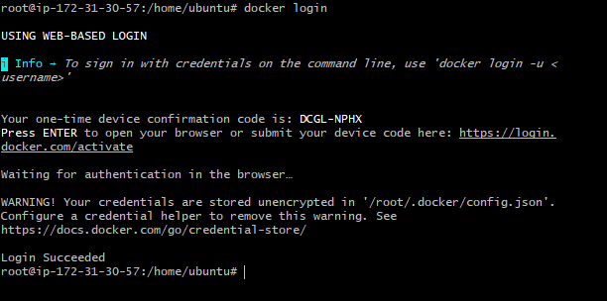
Created a docker account
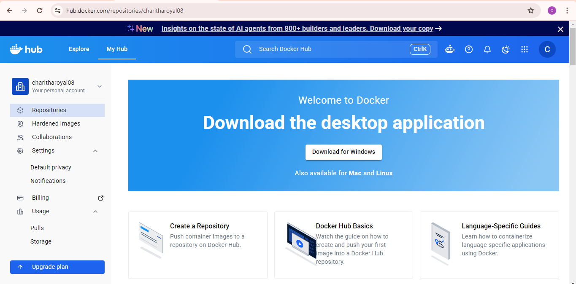
docker tag nginx-custom:v1 charitharoyal08/nginx-custom:v1
docker images
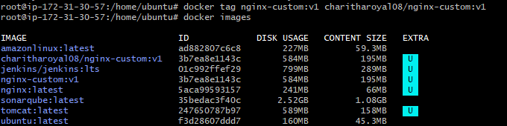
docker push charitharoyal08/nginx-custom:v1
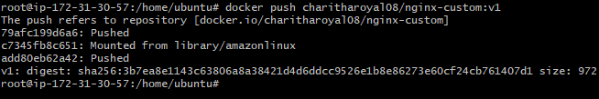
Successfully Pushed image to Docker hub

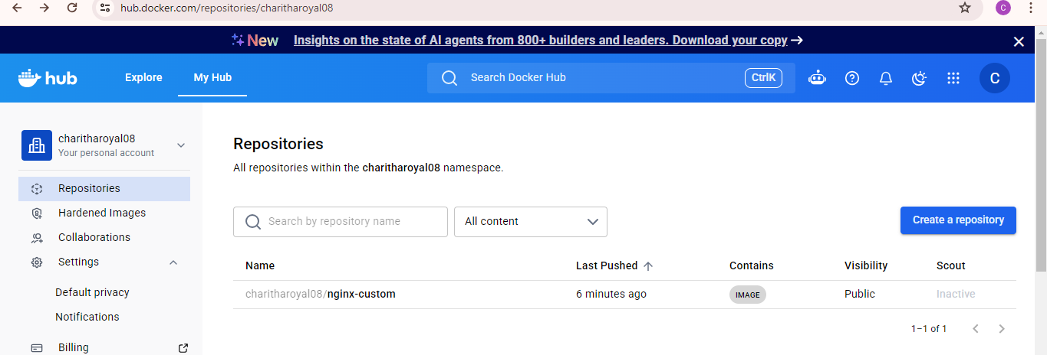
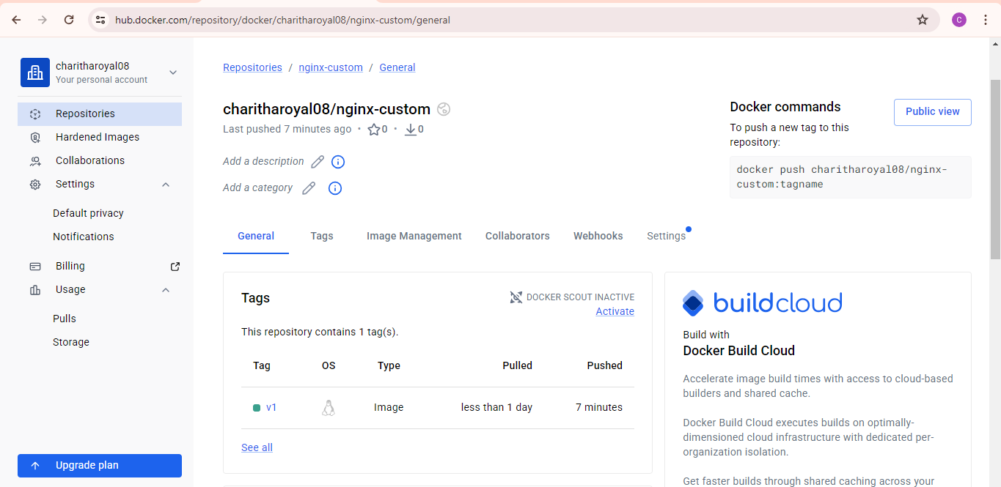
- push image to AWS ECR
apt install awscli -y
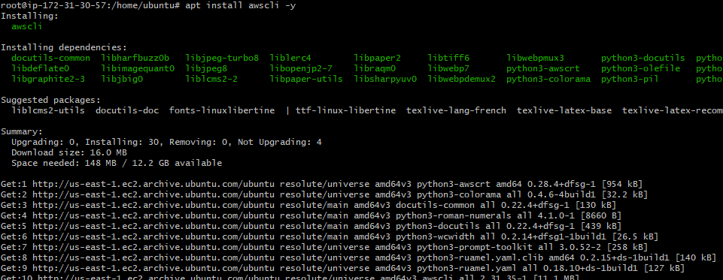
aws –version
aws configure
aws sts get-caller-identity
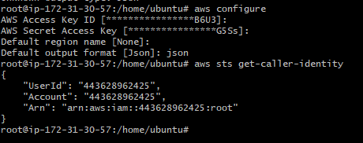
login to aws ECR
aws ecr get-login-password --region us-east-1 | docker login --username AWS --password-stdin 443628962425.dkr.ecr.us-east-1.amazonaws.com 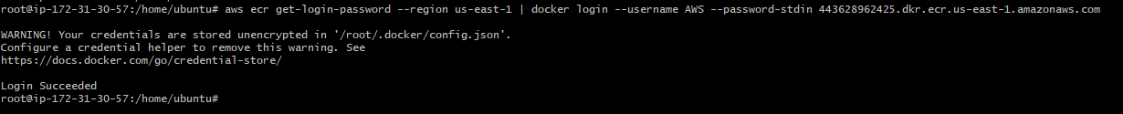
aws ecr create-repository --repository-name custom-nginx 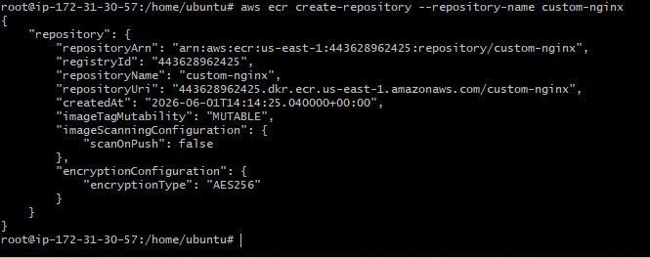
docker tag nginx-custom:v1 443628962425.dkr.ecr.us-east-1.amazonaws.com/custom-nginx:v1docker images
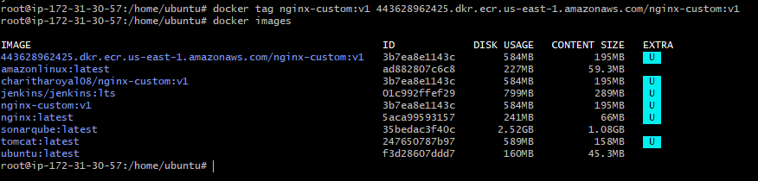
docker push 443628962425.dkr.ecr.us-east-1.amazonaws.com/custom-nginx:v1
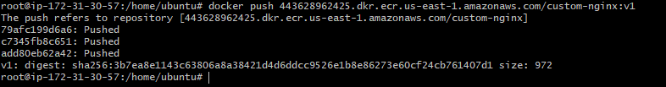
Pushed image successfully
